**Problem Statement**

The goal of this analysis is to assess the performance of pizza sales in 2015 by examining key metrics such as total revenue, order value, and sales volume across different pizza categories and sizes. By identifying top-selling items, daily and monthly sales trends, and category-specific contributions, this analysis aims to reveal actionable insights to optimize pricing strategies, inventory management, and marketing efforts. The ultimate objective is to enhance revenue growth, increase customer satisfaction, and improve operational efficiency by understanding customer preferences and business dynamics in the pizza market.

### ****KPI Analysis****

The KPIs identified for this analysis are as follows:

1. **TOTAL REVENUE:** This KPI represents the overall revenue generated from pizza sales

**Query**: select sum(total_price) as Total_revenue from pizza_sales

**Output**:



1. **Average Order Value:** Measures the average value of each order.

**Query**: select sum(total_price)/count(distinct order_id) as Avg_Order_value from pizza_sales

**Output**: The overall quantity of pizzas sold.

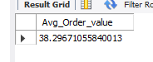

1. **Total Pizza sold:** The overall quantity of pizzas sold.

**Query**: select sum(quantity) as Total_pizza_sold from pizza_sales

**Output**:

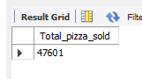

1. **Total Orders:** The count of unique orders placed.

**Query**: select count(distinct order_id) as Total_order from pizza_sales

**Output:**

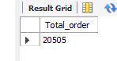

1. **Average Pizza Per Order:** Calculates the average number of pizzas per order

**Query**: SELECT

CAST(SUM(quantity) / COUNT(DISTINCT order_id) AS DECIMAL (10 , 2 )) AS Avg_pizza_per_order

FROM pizza_sales

**Output**

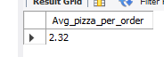

### ****Trend and Insights****

This section provides insights into order trends over time and customer preferences across different pizza categories and sizes.

#### **Order Trends**

1. **Daily Trend For total Orders**

Identifies patterns in order volume by day of the week.

**Query**: SELECT DAYNAME(STR_TO_DATE(order_date, '%Y-%m-%d')) AS order_day,

COUNT(DISTINCT order_id) AS total_orders

FROM pizza_sales

GROUP BY DAYNAME(STR_TO_DATE(order_date, '%Y-%m-%d'));

**Output**

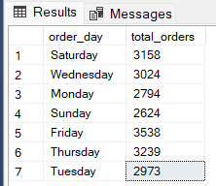

1. **Monthly Trend for total Orders:**

Helps identify peak months in terms of order volume

**Query** : select monthname(STR_TO_DATE(order_date, '%Y-%m-%d')) as Month_Name, COUNT(DISTINCT order_id) as Total_Orders

from pizza_sales

GROUP BY monthname(STR_TO_DATE(order_date, '%Y-%m-%d'))

**Output**

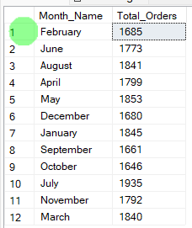

***Sales Distribution by Category and Size***

1. **% of Sales by Pizza Category**

Shows which categories generate the highest percentage of sales.

**Query** : SELECT pizza_category, CAST(SUM(total_price) AS DECIMAL(10,2)) as total_revenue,

CAST(SUM(total_price) * 100 / (SELECT SUM(total_price) from pizza_sales) AS DECIMAL(10,2)) AS PCT

FROM pizza_sales

GROUP BY pizza_category

**Output**

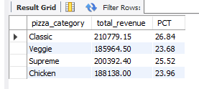

1. **% of Sales by Pizza Size**

Provides insights into the revenue contribution of different pizza sizes.

**Query** : SELECT pizza_size, CAST(SUM(total_price) AS DECIMAL(10,2)) as total_revenue,

CAST(SUM(total_price) * 100 / (SELECT SUM(total_price) from pizza_sales) AS DECIMAL(10,2)) AS PCT

FROM pizza_sales

GROUP BY pizza_size

ORDER BY pizza_size

**Output**

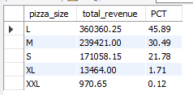

1. **Total Pizzas Sold by Pizza Category**

Highlights the best-selling pizzas by revenue and quantity, useful for inventory and promotional strategies.

**Query** SELECT pizza_category, SUM(quantity) AS Total_Quantity_Sold

FROM pizza_sales

WHERE MONTH(STR_TO_DATE(order_date, '%Y-%m-%d')) = 2

GROUP BY pizza_category

ORDER BY Total_Quantity_Sold DESC;

**Output**

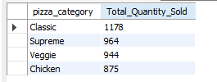

1. **Top 5 Pizzas by Revenue**

Highlights the best-selling pizzas by revenue and quantity, useful for inventory and promotional strategies.

**Query** SELECT pizza_name, SUM(total_price) AS Total_Revenue

FROM pizza_sales

GROUP BY pizza_name

ORDER BY Total_Revenue DESC

Limit 5

**Output**:

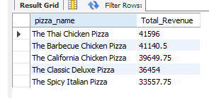

1. **Bottom 5 Pizzas by Revenue**

Identifies pizzas with low sales for potential adjustments or discontinuation.

**Query:** SELECT pizza_name, SUM(total_price) AS Total_Revenue

FROM pizza_sales

GROUP BY pizza_name

ORDER BY Total_Revenue

Limit 5

**Output:**

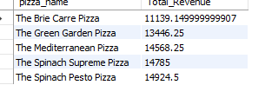

1. **Top 5 Pizzas by Quantity**

Highlights the best-selling pizzas by revenue and quantity, useful for inventory and promotional strategies.

**Query:** SELECT pizza_name, SUM(quantity) AS Total_Pizza_Sold

FROM pizza_sales

GROUP BY pizza_name

ORDER BY Total_Pizza_Sold DESC

limit 5

**Output**

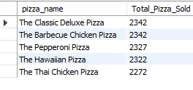

1. **Bottom 5 Pizzas by Quantity**

Identifies pizzas with low sales for potential adjustments or discontinuation.

**Query** SELECT pizza_name, SUM(quantity) AS Total_Pizza_Sold

FROM pizza_sales

GROUP BY pizza_name

ORDER BY Total_Pizza_Sold

limit 5

**Output**

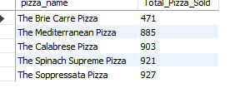

1. **Top 5 Pizzas by Total Orders**

Highlights the best-selling pizzas by revenue and quantity, useful for inventory and promotional strategies.

**Query:** SELECT pizza_name, COUNT(DISTINCT order_id) AS Total_Orders

FROM pizza_sales

GROUP BY pizza_name

ORDER BY Total_Orders DESC

limit 5

**Output**

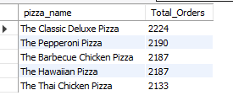

1. **Bottom 5 Pizzas by Total Orders**

Identifies pizzas with low sales for potential adjustments or discontinuation.

**Query** SELECT pizza_name, COUNT(DISTINCT order_id) AS Total_Orders

FROM pizza_sales

GROUP BY pizza_name

ORDER BY Total_Orders

limit 5

**Output**

